Western Front Association
Northumberland Branch
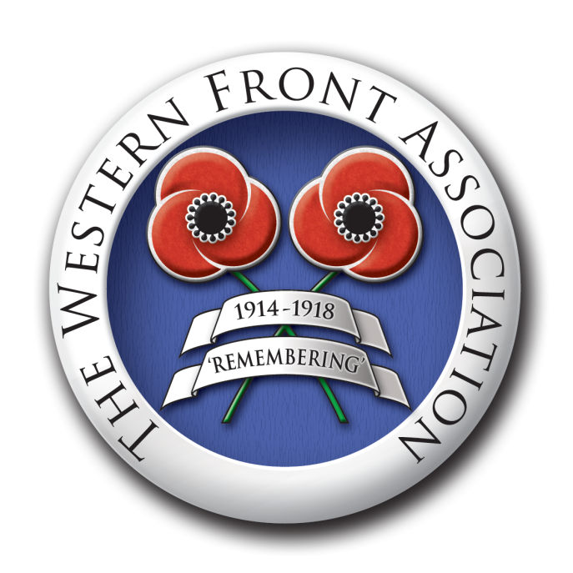
2015 Speaker Programme Reports
23 February 2015
Cliff Pettit spoke on ‘The 1st Day of the Battles of the Somme’.
So engrained in the psyche of people throughout Britain are the events of that day, 1st July 1916, as representing one of the worst military blunders in the history of the British Army – the ‘Lions led by Donkeys’ concept promulgated years after the event by a number of prominent military historians and politicians – that many fail to recognise the need to understand the background and build-up to what happened rather than focus on the events which actually took place, to fully understand them.
Cliff emphasised that selection of the place and timing of the battle were political considerations not of the choosing of General Sir Douglas Haig, Commander-in-Chief of the BEF, who would have preferred an offensive in Flanders later in 1916.
To that time, the French were not overly impressed with the performance and contribution of the British Army, very much the junior partner in the Alliance. As a policing force for the British Empire, it had never been organised, trained or equipped to conduct the sort of campaign other major European powers were capable of undertaking.
The Somme area was chosen because that’s where the boundaries of British and French Armies met. The BEF became lead protagonist in conduct of the Battles of the Somme due to the fact that the Germans pre-empted the Allied offensive with one of their own in February 1916 targeted at Verdun. Strategically, they intended to ‘bleed the French dry’, which nearly happened, so, in turn, the Somme offensive was intended to ‘bleed the Germans dry’ thereby relieving pressure on the French at Verdun. To this end the Allies final goal was achieved albeit at great cost.
Other contributory factors to the disaster on 1 July, included: Insufficient heavy artillery; Defective artillery ammunition fuses; Faulty tactics determined by a mistaken belief in the effectiveness of the lengthy artillery barrage; Ineffective co-ordination between infantry and artillery formations, which techniques were developed and refined in later stages of the battles; and inadequate intelligence on the strength of German defences.
British casualties on 1 July numbered over 58,000 men almost 20,000 of whom were killed. As Cliff went on to say, perhaps the day should be viewed as the first of an extremely steep learning curve for the British Army which, eventually, led to it becoming the most effective and efficient army engaged on the Western Front in 1918.
The WFA’s next formal meeting will be on Monday 23 March when members can enjoy a visit to the Fusiliers Museum at Alnwick Castle.

The next talk at our normal venue will be on 27 April when Sean Godfrey will speak on a 1915 theme.

WFA meetings take place at 7.15pm (for 7.30pm) at Alnmouth and District Ex-Servicemen’s Club, Northumberland Street, Alnmouth. A warm welcome awaits visitors and WFA members new to the branch. The suggested minimum donation is £2, to include a light finger supper.

6 March 2015

