‘Tribute to the Fallen, 1914-1920: Men of Alnwick, Amble, Rothbury & Wooler districts’
What’s it all about?
Object; Availability; Legacies from Alnwick District WW1 Centenary Commemoration Group; Online database; The case for an abridged version of the database; An early training fatality: Private William Cameron; General Officers Commanding were not immune: Brigadier General James Foster Riddell; A strange & tragic tale: Private John Edward Grey (alias for William Cole); Ensuring preservation & future accessibility; For those who may want a copy of the database; Analysis by numbers; A concise overview of the First World War (strictly from a British perspective); Research approach adopted; ‘Soldiers Died in the Great War, 1914-1919’; Local communities covered by the database; Postal Towns in 1914-1918; About Northumberland Branch of the Western Front Association (WFA); Author; Acknowledgements; &, Not forgetting those who returned.

Object
Underwritten by Northumberland Branch of the WFA, in particular through the generosity of the late Bill Foote, DFC, ‘Tribute to the Fallen, 1914-1920…’ is a book by David Thompson, MLitt, which was published in September 2019 (Wanney Books; ISBN 978-1-9997905-7-8). Its object is to deliver for the reader a clear insight into, & better understanding of, the background of those local men who laid down their lives in the First World War in the service of their country; their origins; parentage; siblings; education; pre-enlistment occupations; their wives & children; service records; & more.

Dave Barras, Northumberland WFA Branch Secretary, articulates what it’s all about:

‘The many stories extracted from the online database for use in later Chapters of this book, supported by an abridged version of the database at the end of the book, provides a comprehensive record of the service & sacrifice of men from the wider Alnwick area during the Great War of 1914-18. As this war has moved out of living memory, it’s important we don’t forget the significant impact that conflict had on our communities & citizens. Our hope is that through these pages readers are able to better place the events of 1914-18 in context & reflect on their impact on our wider community.’

Availability
‘Tribute to the Fallen, 1914-1920…’ is not available for commercial sale, rather the print-run of 185 copies was offered & distributed as complimentary copies to the likes of: Archives, museums & libraries; Town & Parish Councils; Local universities & schools; Local history community groups; Members of the public who contributed to the database; Authors of secondary sources drawn upon; Local press; Members of the WFA Branch; & various others.
Legacies from Alnwick District WW1 Centenary Commemoration Group

Supported by grants from the Heritage Lottery Fund & the national WFA, at the end of 2012 Alnwick District WW1 Centenary Commemoration Group set about delivering an ambitious programme aimed at commemorating the first two centenary years of the First World War but especially 1915. The core of the Group was drawn from members of Northumberland Branch of the WFA, Alnmouth & District Branch of the Royal British Legion, & people from the education field.

The project was made up of five areas of activities & focused on schools & education; IT, including building a searchable database of casualties from the area; heritage; events in 2015 commemorating the Northumberland Fusiliers’ Tyneside Scottish Brigade’s time at & around Alnwick (these men were Kitchener Volunteers); & production of a WFA-sponsored DVD ‘Alnwick 1915 - An Armed Camp’ relating the story of Alnwick Camp built on the pastures opposite Alnwick Castle where the Brigade carried out its initial training. In addition, the Group contributed to publication of three books.

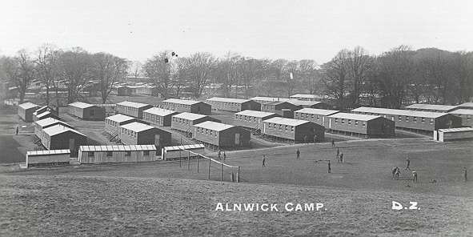
Alnwick Camp, 1915 (Courtesy of Cliff Pettit)

Online database
Progressive versions of the WFA’s database of First World War fatalities amongst men born & / or resident & / or enlisted in the wider area, have been available online since May 2013 courtesy of Bailiffgate Museum, Alnwick - https://bailiffgatecollections.co.uk/world-war-1/.

In the latest update, data provided includes a man’s full name; regimental / unit service number; rank; regiment / naval unit / squadron; date of death; age; where commemorated (or buried, if found); service history; background; local memorials, &, in many cases, attached photograph(s).
The case for an abridged version
While the online database has been suitable for those researching individual fatalities, it is of more limited use to anyone interested in knowing more about the wider area’s overall contribution to the nation’s war effort, & the impact the First World War must have had on local families & communities. It is for this reason that the Branch decided to publish & distribute the database, so that local communities & individual researchers can view & analyse it in totality.
The stories of over 170 men have been extracted from the database & are presented more fully in Chapters 4-9 of the book. For illustrative purposes, three examples follow, below, for Private William Cameron; Brigadier James Foster Riddell; & Private John Edward Grey (alias for William Cole).
For others, limited space in printed form precludes inclusion of everything available online, so an abridged version of the database is presented in the book with service & family backgrounds largely merged & edited, & information on local memorials omitted. Researchers keen to find out more on where a man or men might be commemorated in the North East of England can do no better than visit the North East War Memorials Project website at www.newmp.org.uk.
Producing an abridged version of the database has been an enormous task for the book’s author, David Thompson, involving a complete re-write of the original. On a positive note, this allowed minor errors & omissions in the original to be addressed, as well as to introduce abbreviations, so enabling publication of data in a readable A-4 format.
As Mo Dewar, a Branch Committee member, succinctly puts it:
‘Whether you are tracing a family tree, investigating an aspect of the First World War, or researching the history of Northumberland, you will find this detailed compendium a valuable & fascinating resource.’
An early training fatality: Private William Cameron

Private William Cameron, 21, died on 14 October 1914, as a result of a tragic accident during training for service overseas, at Gosforth Park Camp. Cameron served with the Northumberland Fusiliers, 1/7th Battalion Territorial Force, ‘C’ Company. While crossing the Blyth & Tyne Sections of the North Eastern Railway line between Backworth & Monkseaton Stations, at 10:15 hours on 14 October 1914 he accidentally stumbled, fell onto the electrified rail & was electrocuted.

The 'Berwick Advertiser', 23 October 1914, gave a detailed account of events. 'Accidental Death' was the verdict returned at an inquest held at Newcastle Royal Victoria Infirmary (RVI). It was reported that the Company had crossed the railway line at Benton Station, word having been passed down the line to beware of the 'live' rail, but it happened that Cameron had reason to re-cross the rail when he stumbled & fell. Lance-Sergeant N. Wright of the Royal Army Medical Corps gave evidence to record Cameron was dead when he reached him. Cameron had burns across both knees, his face, & on the thumb.

Cameron was born on 11 March 1893, in the Belford area of Northumberland, the son of George Robson & Barbara Cameron. Educated at Belford National School, on leaving school he was apprenticed to William Johnson, a joiner, & lived with him at Belford before moving to Alnwick.

His funeral took place at Newcastle from the RVI. 'C' Company provided a full military service with firing party & under-bearers, & there was a large attendance of men from the Camp.
General Officers Commanding were not immune: Brigadier General James Foster Riddell
Born on 17 October 1861, Brigadier General James Foster Riddell was the only son of the late John Riddell (5th in descent from the Rev. Archibald Riddell, 3rd son of Sir Walter Riddell, 2nd Baronet of Riddell, Roxboroughshire, Scotland) & his first wife, Jane, daughter of William Peppercorn.

Educated at Wellington & the Royal Military Academy Sandhurst, Riddell married at St. Mary Abbots, Kensington, 12 April 1912, Margaret Christabel (of Lesbury House, Lesbury, Northumberland), daughter of the late Sir Henry Scott (well-known in Northumberland, & of Eilanreach, Invernesshire).
First commissioned as an Officer in the Northumberland Fusiliers in 1881, Riddell served in campaigns in Africa between 1888 & 1902. When the First World War broke out in August 1914, he was appointed to command what became the 149th Infantry Brigade, which was made up of the Territorial Force battalions of the Northumberland Fusiliers, including many local men in the 7th Battalion based at Alnwick.
Initially the Brigade was tasked with guarding the North-East coast but, after the Regular Army suffered heavy losses in the opening battles of the war, Territorial Force units were soon sent overseas. The Northumberland Brigade went in mid-April 1915, initially to be put in reserve near Ypres, Belgium.

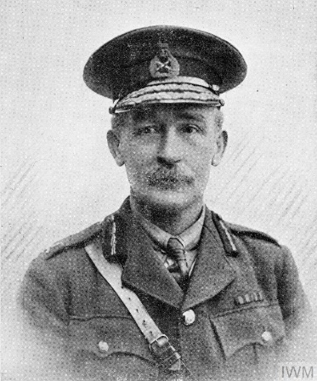
Brigadier General James Foster Riddell (1861-1915)
GOC, 149th Infantry Brigade (Northumberland), 50th Division (Northumbrian)

On 22 April 1915, the German's unleashed poison gas for the first time in war & terrified French troops ran away rather than be choked, leaving a significant gap in the Allied lines & the threat of a German breakthrough & the loss of Ypres. The Northumberland Brigade was rushed to the front in commandeered London buses &, on 26 April, it was ordered to counter-attack alongside the Lahore Indian Division, from the village of St Julien, north of Ypres.

As the Northumberland Fusiliers pushed forward, they were exposed to heavy machine gun & artillery fire. Although this prevented them from pushing the Germans back it helped to re-establish the line.

The cost was high, with over 2,000 casualties, including many local men. Brigadier General Riddell was one, hit in the head as he conferred with his officers in front-line trenches. He is buried with 11,871 British & Commonwealth soldiers at Tyne Cot Commonwealth War Graves Commission Cemetery. He was 52 years old & had been on the Western Front only a week.

A strange & tragic tale: Private John Edward Grey (alias for William Cole)

As John Edward Grey, William Cole enlisted in the Border Regiment at Carlisle in August 1915 when he was 38. In September 1916, the 6th Garrison Battalion of the Royal Welsh Fusiliers was raised at Aintree, Liverpool. Such battalions were usually formed with men too old or too unfit for front-line service. It can only be assumed Cole / Grey met the criteria & transferred to the Fusiliers.
It's known he visited Embleton in October 1916, staying for three nights with a William Robert, a Quarryman. At about 20:45 on the evening of 13 October he left intending to catch a train to Liverpool where his battalion was stationed.

On the following Saturday (17 October), a John Robertson found the body of Cole / Grey hanging beside a hay stack at Stamford Farm. By some means the Police established his next-of-kin & his wife, Sarah, identified the body as Cole / Grey as she recognised the verses of poetry found on the body as his. An inquest held in Embleton, on 27 October, found that he committed suicide.

The grave of William Cole is in Spitalford graveyard, Embleton. As far as is known Cole was not born at Embleton nor was he educated there, nor did he live there. The headstone was erected by the Commonwealth War Graves Commission (CWGC).

After the First World War ended, the relevant service authorities supplied the CWGC with all their casualty information including next of kin, etc. A 'Final Verification Form' was sent to next-of-kin to confirm the casualty's personal details, fill in any blanks &, where applicable, provide a personal inscription for the headstone. Due to the sheer size of the task this took many years to complete & was still underway in the 1930s.

By the end, over 1 million forms had been sent out. In the case of William Cole, it would appear the CWGC did not manage to contact his next-of-kin & his details were provided by the military authorities who were aware of his use of John Edward Grey as an alias. The authorities were often aware of men signing up & using assumed names. They had a procedure in place to amend a man's service documents, & it was his choice as to which name he continued to be known by.

William Cole was born in 1876 at Moor House, Durham. His father, Matthew, was, in 1871, a Foreman with the North Eastern Railway Company, living in Railway Terrace, York, with his wife Elizabeth (née Turnbull) but later (1881) he was employed as a Steam Boats' Engineer &, in 1891, as a Grocer in York. Cole had an older sister, Kate (b. about 1872), who eventually became a Dressmaker.

In 1901 Cole (known as Willie) was boarding at Stockton-on-Tees & working as a Joiner's Labourer. Later that year he married Sarah Elizabeth Wilkinson in York where they set up home.
They had four children – Kathleen; William; Harold; & Charles, the last being born in 1908. Cole left his wife in 1909. In 1911 she was living with their children in York & working as a Domestic Laundress.

There is no sign of Cole in the 1911 Census. It appears he adopted the name John Edward Grey to avoid his wife & creditors!

Ensuring preservation & accessibility for the future
To ensure the database content created remains safe & accessible for future generations, as well as with Bailiffgate Museum the WFA Branch is working with Northumberland Archives & North East War Memorials Project, to capitalise on preservation of their websites for the future in the UK Web Archive, by having the WFA’s database embedded & integrated within their website platforms.

Paul Ternent (Northumberland Archives) has said:

‘We are pleased to offer our support to this worthwhile project. It’ll be a fantastic resource for our users to work with & complement our existing finding aids.’

For those who may want a copy of the database
Online versions of the database are not available for downloading however the Branch will be receptive to requests from researchers, students, community groups & institutions for copies to be made available, to aid their researches. A brief explanation of what the complete database will be used for, and how it will be used, would be appreciated, on application. An email box has been created specifically to handle any such requests – tttffww@gmail.com.
Analysis by numbers
Chapter 2 of ‘Tribute to the Fallen, 1914-1920…’ provides various brief analyses of the database summarising such as: Family names; Forenames; Ranks; Regiments; Years of death; Ages; Where commemorated; Families to lose two or more sons; and, Decorated men with local connections who were lost. A copy is available as a separate piece using the ‘Find out more’ box on the website’s home page - https://bailiffgatecollections.co.uk/world-war-1/. Similarly copies of the Appendices recording family names recorded in the database & families to lose two or more sons, are also available via this route.
A concise overview of the First World War (strictly from a British perspective)
In an endeavour to provide context & perspective, the fifty-six pages of Chapter 3 offers readers a complete history of the First World War in bullet-point format. The Chapter covers the pressure for Army reforms at the close of the nineteenth century; Origins of the First World War; Army preparations for the long-expected conflagration & organisation; Britain’s intended strategy; Irish affairs; Britain in 1914; The spark that lit the touch paper; War Aims; Mobilising the Armed Forces; Mobilising & managing the economy; Support from the Empire; Use & effectiveness of propaganda; A very different form of warfare, life in the trenches; Key dates, campaigns, battles & engagements, on a year by year basis; War weariness; Importance of the United States of America to the Allied victory; Training of the Army; Evolution of Army tactics; Technological advances; 1918 German Spring Offensives; Allied ‘Advance to Victory’; Armistice; Versailles Peace Treaty; Casualties; 1918-1920 influenza pandemic; Psychological impact of the First World War on British Society; & final Conclusions on the War.
Again, a copy is available as a separate piece to access & download using the ‘Find out more’ box on the website’s home page - https://bailiffgatecollections.co.uk/world-war-1/.

Research approach adopted
Data has been compiled from a wide range of sources including:
- The Internet (notably Commonwealth War Graves Commission; Ancestry.co.uk for a whole range of information available from searches of military records & Census data; Culturepics.org; Findagrave.com; & more);
- North East War Memorials Project;
- Local history societies (of which Amble & District, & Coldstream & District Local History Societies are good examples);
- Specialist CD-ROMs (e.g., ‘Soldiers Died in the Great War 1914-1919’; ‘The War Gazettes 1914-1919’; ‘War Diaries of the Battalions that fought on the Western Front’);
- Specialist publications (e.g., ‘UK, de Ruvigny’s Roll of Honour 1914-1918’; ‘The Bond of Sacrifice…’; ‘British Regiments, 1914-1918’; ‘Cemeteries & Memorials in Belgium & Northern France’);
- Printed works from local project groups & others (e.g., Amble; Chevington; Embleton; Felton; Howick; Rothbury & the Coquet Valley; Warkworth & Acklington);
- Descendants of some of those included on the database, many of whom have provided photographs that might otherwise be lost to posterity;
- Old issues of the ‘Alnwick & County Gazette’ available at Northumberland Archives, Woodhorn, Queen Elizabeth II Country Park, Ashington.

‘Soldiers Died in the Great War, 1914-1919’
In 1921 His Majesty’s Stationery Office published, on behalf of & by authority of the War Office, two lists of those who died during what, then, was referred to as the Great War. One volume gave the basic details of nearly 42,000 officer casualties. It required a further eighty volumes to list the 662,000 ‘Other ranks’ (ORs) who gave their lives in a war that claimed a daily average of over 450 British Army fatalities.
Each of the original volumes relating to ORs represented one or more regiments, corps or other units of the British Army. Most were subdivided into battalions or similar groupings. There were often thirty or more of these per volume, each in near alphabetic order. The task of searching through all volumes for a name was immense. The possibility of gleaning other information such as all those born in a certain town or all those who died on a certain date, was virtually impossible.
The specialist publisher Naval & Military Press Ltd (N & MP) identified the potential for digitising things on one fully relational CD-ROM. First issued in 1998, its searchable format allows flexible interrogation of over 703,000 records. Publication of version 1.0 rewrote the rulebook & placed N & MP in the forefront of serious military publishing.
In 1999 version 1.1 was published; version 2.0 followed in 2004; & version 2.5, the current version (January 2020), was published in 2011. This allowed N & MP to take advantage of operating systems advances, to carry out a complete overhaul of functionality.

Local communities covered by the database

Acklington | Acton
Adderstone | Alnham
Alnmouth | Alnwick
Alwinton | Amble
Bamburgh | Belford
Biddlestone | Bolton
Boulmer | Broomhill
Callaly | Chatton
Chevington | Chillingham
Christon Bank | Craster
Denwick | Doddington
Doxford | Edlingham
Eglingham | Ellingham
Elsdon | Embleton
Eshott | Felton
Glanton | Great Tosson
Guyzance | Hadston
Hauxley | Hepple
Holystone | Howick
Ilderton | Ingram
Kirknewton | Lesbury
Lilburn | Linhope
Longframlington | Longhoughton
Lucker | Netherton
Newton-by-the-Sea | Newton on the Moor
North Charlton | North Sunderland
Powburn | Radcliffe
Red Row | Rennington
Rock | Roseden
Rothbury | Seahouses
Shilbottle | South Charlton
Swarland | Swinhoe
Thirston | Thropton
Thrunton | Warenford
Warkworth | West Fleetham
Whittingham | Wooler
Wooperton

Postal Towns in 1914-1918
Post Towns existed long before the introduction of post codes, which may give rise to a few surprises for today’s researchers. For example, Lesbury extended far afield to include Newton-by-the-Sea & Embleton; Acklington was the Post Town for both Amble & Warkworth.
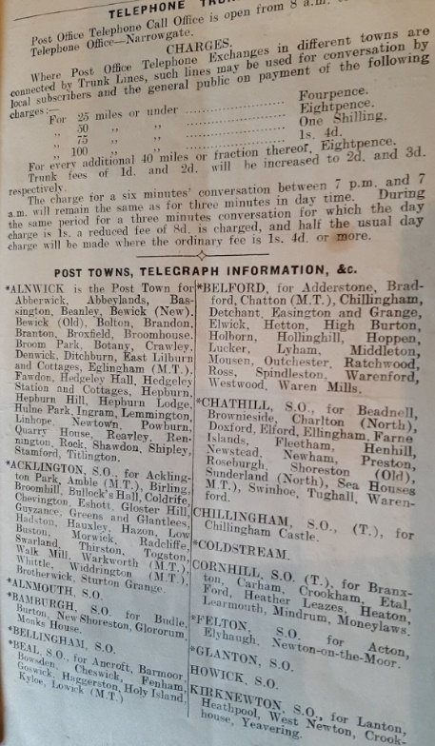
Post Towns taken from the 'Alnwick & County Gazette' 1916 Almanack
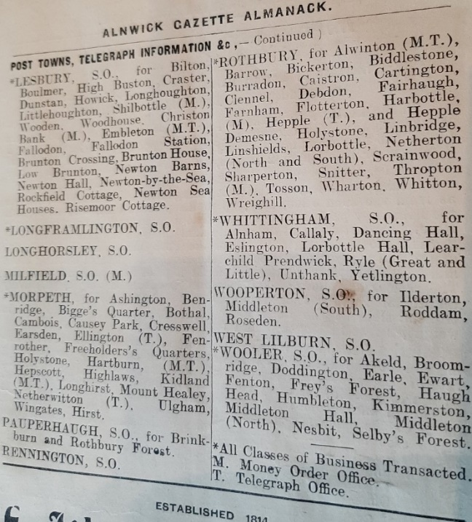

About Northumberland Branch of the Western Front Association
Currently, Northumberland Branch of the WFA usually meets on the fourth Monday of every month (except August & December) at Alnmouth & District Ex-Servicemen’s Club & Institute, Northumberland Street, Alnmouth. Meetings take place at 19:15 hours (for a 19:30 start).

Web & social media links advertising branch’s speaker programme(s) are to be found at:
- WFA Branch link – http://www.westernfrontassociation.com/branches/united-kingdom/northumberland/;
- Facebook page link – https://www.facebook.com/WFANorthumberland/.

A warm welcome awaits visitors & WFA members new to the Branch. The suggested minimum donation is £3 per person, to include a light buffet.
More information on the WFA nationally is to be found at: http://www.westernfrontassociation.com.

Author
David Thompson was awarded a Master of Letters in History degree (with Merit) in 2002 by Newcastle University for his dissertation on the Durham Light Infantry Regiment in the First World War.

As a WFA member, David is author of a wide range of talks & published articles on the First World War. Several articles have been published in ‘Stand To!’, the prestigious national journal of the WFA. More recently, David has been a regular contributor of articles for publication in the ‘Northumberland Gazette’, the local weekly paper for North Northumberland. These include, in 2016, a four-part, centre page series on the Battles of the Somme; in 2017, a similar series on the 1917 Flanders Offensive including the 3rd Battles of Ypres, more commonly known as Passchendaele; &, in 2018, a two-piece article commemorating the centenary of the signing of the Armistice.
Acknowledgements
Completion, & publication, of the database would not have been possible without the generosity of the late Bill Foote, DFC who donated the proceeds from sales of his memoirs as a Second World War Halifax bomber pilot (‘Me, the RAF & 77 Squadron’; Produced & edited by David Thompson; ISBN 978-0-9927324-3-1; Wanney Books; 2014) to largely cover the cost of this more recent enterprise.

Bailiffgate Museum warrants special thanks for hosting the database’s online presence since 2013. Thanks, also, to Paul Ternent, Rob Fitzgerald & Sarah Littlefear at Northumberland Archives, which will be hosting an online presence; & to Janet Brown & her colleagues at North East War Memorial Project, for their tremendous help & support throughout, & who will also be using the database to supplement their own website.
Thanks, too, for the continued moral support from Branch Committee colleagues – Neil Brison; Dave Barras; Mo Dewar; & Colin Buxton.
Other sources of personal research material for the database include:
Christine Allin (Lancelot Borrell);
Margaret Allison (via North East War Memorials Project [NEWMP]; Privates Andrew Dane & Thomas Vosper);
William Ballance (Private William Henry Harbottle; with credit for finding the material to a member of Coquet & Coast Forum);
Romaine Barclay-Kim (Private Thomas Edgeley Barclay);
Joyce & Neil Brison (For masses of information & photographs on a wide range of men from the area);
Colin Boyd (via NEWMP; Private George Patterson);
Margaret Burgess (via NEWMP; Private Walter Brown);
Carolyn Campbell (Private Thomas Scott);
Eileen Duncan (via NEWMP; Private Robert Nicholson);
Carolyn Egglestone (Acting Sergeant Walter Richardson);
Garth Flack (Private John Burn);
Dudley & Mary George (Various; & Dudley for help in compiling early versions of the database & for ongoing assistance in his role as Webmaster for Bailiffgate Museum);
Derek Gladding (Warkworth men);
Jane Glass (Company Sergeant Major [CSM] Thomas Chrisp, MM; & help in compiling early versions of the database);
Pat Graves (Glanton & Whittingham);
Michael Grant (2nd Lieutenant Roger Marshall; & CSM George Anderson, DCM, MM, MSM);
Ian Hedley (CSM George Anderson, DCM, MM, MSM);
Eric Inglis (Private Andrew Inglis);
Steven Ions & his colleagues at Team Valley Web Design (for managing uploads to Bailiffgate Museum’s website);
Patricia Jones (Ernest Miller Watts; & the three Young brothers, Arthur Cecil, Charles Edward, & William Lawrence);
Derek Johnstone (via NEWMP; Private Joseph Daniel J. Potter);
Rose Knox (Thomas Egdell & his brothers);
Helen & Mick Lewis (Private John W. Moffatt; also, men of Amble & surrounding areas);
Derek Mallon (Sergeant Michael Mallon);
Vera Mallon (Sergeant Michael Mallon);
Peggy Maunder (Edlingham War Memorial Tablets);
Brian McFall (Private Alexander James Davidson);
Shirley Milligan (Private James Davidson);
Robert (Bob) Moore (Sergeant Adam Tait, DCM);
Ken & Ann Morrison (Private John William Lightbody);
Pam Muggleton & Alnmouth Local History Group (Alnmouth men);
Phil Pain (Major William Burrell);
Derek Pheasant (credited by Framlingham College for additional information on 2nd Lieut. William Hudson Milburn; www.oldframlinghamian.com/gallery2/);
David Pullan (Private Charles Edward Bonnier);
Mike Punton (Corporal James Herbert Punton);
Pauline Priano (Regimental Quartermaster Sergeant Ernest Williamson);
Paul Reed (Private Andrew Hanton);
David Richardson (Private Matthew Brown Wight);
Janet Rice (via NEWMP; Private Arthur Charles Titheridge);
Allan Ritson (Lieutenant Frederick Anderson Brown);
Tony Simpson (Private William James McLaren Humble);
Amanda Sinton-Gerry (Gunner Robert Stephenson);
John Thompson (Private Alfred Thompson);
Chris Thorp (2nd Lieutenants Thomas Tudor Thorp & Robert Oakley Vavasour Thorp, MC);
Jenny Ulph (Captain William Wallis Everett);
Pierre Vandervelden (Bousebecque Communal Cemetery, Nord France; Flight Sub-Lieut. Donald Wyand Ramsay);
Robert Wake (Private Robert Henderson);
Anne Watson (Gunner Edward Naylen);
Julie Wilson (2nd Lieutenant William Bickerton);
Steve Young (Lance-Corporal William Thompson).

Thanks to all for their valued contributions, help & support.

Thanks, too, to Ian Hall of Wanney Books, who has done what all good publishers do, quickly find solutions to periodic technical issues relating to computer applications. His experience & guidance have been greatly appreciated.

Taking on such a daunting undertaking as this would not have been possible without the unstinting support & understanding of my wife, Kath. The time & effort devoted to researching & compiling this work has been enormous. With that great gift of hindsight, had I appreciated at the outset just how much time, effort & commitment would be needed to complete the project, would I have committed so fully to it? Probably not but, having done so, the task has been fulfilling, rewarding & thoroughly enjoyable.

Hopefully the database in both its online form & in its published form will contribute to north Northumberland’s historiography for the early part of the twentieth century by delivering an accessible research resource for the use of students, institutions, local community groups & others with an interest in the First World War years & the impact they had on this area.

Not forgetting those who returned
Inevitably, the database focuses on fatalities. Let us also commemorate the almost 90% of those who served their country & survived the war notwithstanding many will have returned from it scarred for life through physical & psychological injuries.

There is no reason to believe the statistics in relation to local casualties are any different from the national experience, so a reasonably accurate estimate of local men who would have been wounded might be about 3,700-3,800, & the number of men who responded to the call to arms would have been over 12,500.

More details & analysis of First World War casualties is given in the accompanying piece ‘Overview of the First World War‘ available at https://bailiffgatecollections.co.uk/world-war-1/.

David Thompson, MLitt
January 2020

Under the guidance of Geoff Bridges, Editor of ‘Soldiers Died…’ CD-ROM 2.5 on behalf of N and MP: https://www.naval-military-press.com/product/soldiers-died-1914-19-cd-rom-version-2-5/.

